Lab 3
Basic LAN Setup
Objective:
The purpose of this lab is for the student to create a basic LAN. Students will connect and configure PC’s in a LAN. Students will also utilize network commands to test and verify network connectivity between devices.

Diagram:

Components:
6 – PC’s with an Ethernet NIC
1 – Hub

Procedure:
- Connect all PC’s to the hub. Verify that the connectivity light on the hub is active for every PC that is connected.

- Go to the network card properties for IP Version 4 and manually put in the machines IP address.

  - Click Start and type Control Panel in the search field.
  - Click on “Network and Sharing Center”
  - Click “Change Adapter Settings” near the top left
  - One of your NICs should be called Local Area Network. Right click the NIC and click “Properties”
  - Click on “Internet Protocol Version 4” and click “Properties”
  - Click the radio button for “use the following IP address”
  - Enter your IP address and subnet mask. Don’t worry about the default gateway or DNS. Those will be covered in a future lesson.

- Save the configuration and disable the NIC, then re-enable the NIC. Do this by right-clicking the NIC, click disable. Right-click again and click enable.

- Bring up a command prompt and verify the machines IP address has been configured properly by running the ipconfig command. The command prompt can be accessed by clicking start, typing “cmd”, without the quotes, and hitting the Enter key. Next, type “ipconfig”, without the quotes, and hit Enter. Confirm your IP address matches what you configured above.

- Run the ipconfig /all command. Find the mac address of the PC and record it below. Microsoft calls this the physical address.

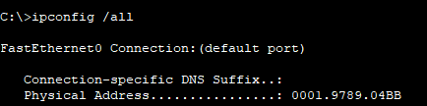
____________________________________________________

- Bring up a command prompt and ping the IP address of another machine in the diagram.

  - Was the ping successful? How can you tell?
Yes; there were four replies:
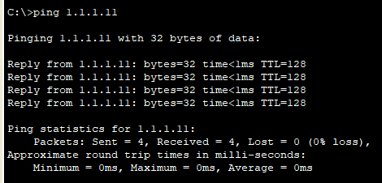
  - Ping the IP address 1.1.1.100.
  - Was the ping successful? How can you tell?
No; there was no response and the request timed out:
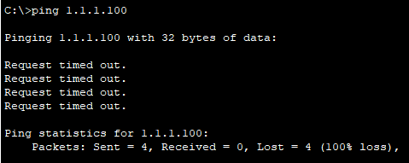
  - Ping 127.0.0.1

  - Was the ping successful? What is this address?
Yes; 127.0.0.1 is a loopback address, which will send a signal that will loop back to the original machine.

- Run the command “arp –a” in the command prompt. There is a space between the arp and they hyphen.

  - List the entries below. You can snap a pic with your phone or copy and paste. Don’t waste your time typing or writing the table.
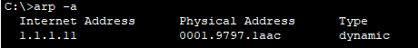
  - Ping all of the PC’s, then run the ARP –a command again.
  - Did the ARP table change? Why?
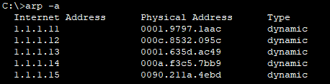
Yes; the table changed because we pinged all of the computers, so the computer discovered their MAC addresses through the process.

- Run the command netstat –a in the command prompt. There’s a space between netstat and the hyphen.

  - What is listed? Network sessions that are open or active on the computer that was entered.
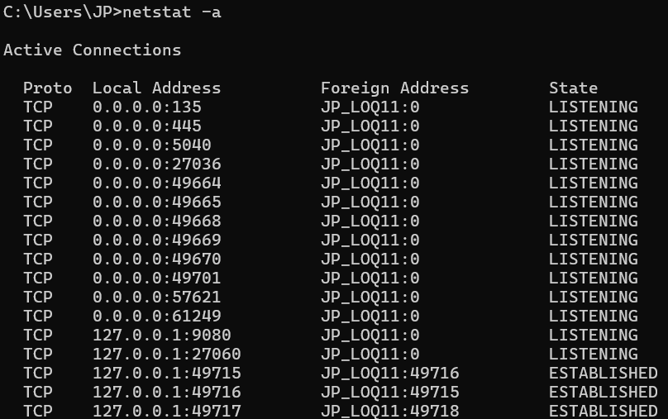
  - Go to an Internet browser and type in \\1.1.1.10
  - Did the table in netstat –a change?
Yes, it did! Opening up a connection on the web to the IP address changed the table:
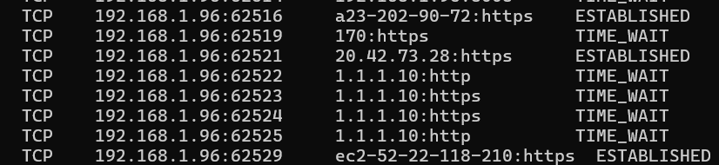

- Run tcpview.exe and observer its table. Try to make another connection to \\1.1.1.10. Tcpview.exe should be in a folder: c:\capal install

  - How is tcpview different from netstat (besides one being command based and the other GUI based.)
The view on netstat seems to only reflect the connection at the time that the command was executed; when I ran netstat again, the 1.1.1.10 was gone. The tcpview seems to update in real time, which will change as the network sessions change.

- What did you learn by completing this lab?

I learned how to manually input a machine’s IP address and subnet mask, find the IP and MAC addresses of a machine using ipconfig /all, ping other machines on a network, obtain and view their MAC addresses with the arp -a command after pinging them, and view network sessions using tcpview and netstat.

